
OPERATION SNOWMAN
2010
DATE: SUNDAY, FEBRUARY 7, 2010
TIME: 8:45 A.M. - 2:00 P.M
PLACE: WOODLAND TRAILS CAMP
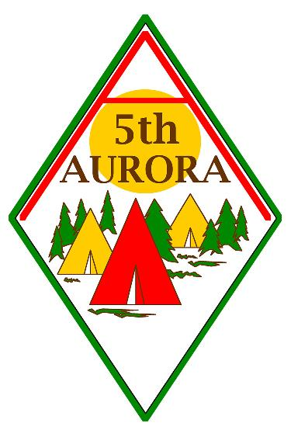

Many Exciting activities!
Log Saw |  | Fill the Bucket
 | Pull the Leader
Broom Ball |  | Camp Fire

 |  | 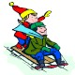
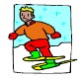 | $10 per Cub/Parent  Your admission fee covers  - An Operation Snowman Crest for each Cub  - Morning Break - Hot Chocolate,  - Light Lunch  - Activities  Make Cheques Payable to 5th Aurora Scouts

Clothing: Please dress weather appropriate – Suitable clothing includes warm underwear, uniform shirt and scarf, warm sweater, waterproof snowsuit, or waterproof jacket & pants, waterproof warm mitts, warm socks, winter waterproof boots, winter hat & extra socks and mitts as Cubs and leaders will be outside all day. Mug for soup and hot chocolate; water bottle

Parking: In designated parking lot. Please car pool as much as possible- parking space is limited
If you will be absent from your normal place of residence during the period when the event is being held, please indicate where you can be contacted:

Name: __________________________________ Phone: ________________
Address: ______________________________ City: ____________________
Province: ____________________________Postal Code: ________________

Youth’s Name: _________________________________________________ Phone: _______________

Address: ____________________________________________Parent’s Name: ___________________

Permission to Participate:
I the undersigned, after having read, understood and completed the information, hereby give my permission for my child to attend and participate in: Operation Snowman at
Woodland Trails on February 7, 2010. I have reviewed the information on my child’s/ward’s physical fitness form and confirm that the information is up to date.

____________________________________ ____________________
Parent or Guardian Signature Date

