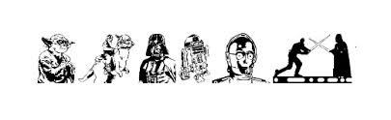
5th AURORA SCOUTING GROUP

Parent/Guardian Consent Form

Event: Star Wars Camp – All Sections (Beavers, Cubs, Scouts)
Date: September 26th – September 28th 2014
Time: 8:00 p.m. Friday to 12:00 noon Sunday
Place: Kitchie Lodge, Camp Samac, Oshawa, Ontario
Cost: $50.00 per youth; $50.00 per Adult

Young Jedi from across the universe are joining forces for a very special event. Please join us for Jedi Training at Star Wars Camp. Space is limited, so decide quickly! May the force be with you!

Youth’s Name: ______________________________ Phone: _______________

Address: ____________________________ Parent’s Name: _______________

Parent also attending camp. Yes □, Name ______________________________

Total $ _____________
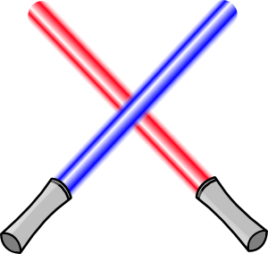
Permission to Participate:
I the undersigned, after having read, understood and completed the information, hereby give my permission for my child to attend and participate in: All Section
Star Wars Camp at Camp Samac 1711 Simcoe St N, Oshawa, ON L1G 4Y1 on September 26th, 2014 to September 28th, 2014. I have reviewed the information on my child’s/ward’s physical fitness form and confirm that the information is up to date.

____________________________________ ____________________________
Parent or Guardian Signature Date

FALL KIT LIST FOR CAMP

Each Cub is required to wear their Uniform to and from Camp
(Gear should be marked for easy identification)

Bedding
Sleeping Bag & Pillow Air mattress or Foam Pad

Extra blanket

Toiletries
Wash Cloth / Towel Toothbrush & Paste
Plate, cup, bowl, cutlery & mesh bag to hold Soap & Comb
Sun Block Bug Repellant

Clothes - dress for expected weather
Two or three changes of clothing Underwear (enough for 3 days)

T-shirts 3-4 Long Pants & shorts
Socks 4-5 pairs Track pants
Pajamas – 2 pairs (extra for emergencies) Splash Pants
Running Shoes (indoor and outdoor) Rubber Boots (if available)
Sweatshirt Jacket / Rain Coat
Campfire Blanket (if available) Toque for Sleeping
Hat for daytime

Miscellaneous
Plastic bags for dirty/wet clothes Paper/Pencil/Pen
Flashlight with spare batteries Teddy Bear/sleep toy
Optional: reading material/comic books Lawn chair
Compass (if own one)

Please no electronic games or pocket knives!
Absolutely no food is to be brought to this camp as there are severe allergies. Food found will be confiscated.

If, in the opinion of the Leaders, your child’s actions prove to be too much to handle, a contact person must be available so that transportation from the camp can be arranged.

Parents please indicate any known food allergies or special needs and inform your section leader as soon as possible prior to camp.

