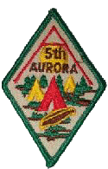
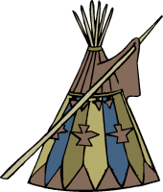
5th AURORA CUBS

Parent/Guardian Consent Form

Event: Aboriginal Awareness Winter Camp
Date: March 25, 2011 – March 27, 2011
Time: 7:30 p.m. Friday to 12:00 p.m Sunday
Place: Big Pine Lodge at Woodland Trails
Cost: $40.00

Learn to speak a few Native Canadian words, play games that are as old as Canada and explore food and traditions of the aboriginal culture. We will have special guests to guide us in our exploration of this culture. The cost for this camp is $40 and space is limited to 40 beds. Please sign up by March 9th to secure your place at this camp! Please note each participant will be need a paper towel roll.
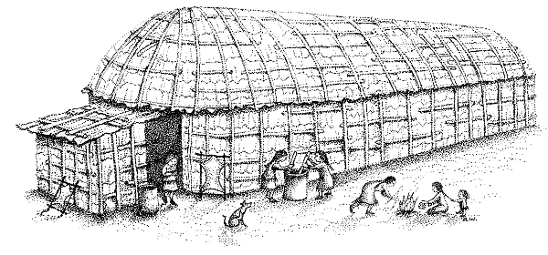



Youth’s Name: ______________________________ Phone: _______________

Address: ____________________________ Parent’s Name: _______________

Permission to Participate:
I the undersigned, after having read, understood and completed the information, hereby give my permission for my child to attend and participate in: Aboriginal Awareness Winter Camp at Woodland Trails Camp on March 25th – March 27th, 2011. I have reviewed the information on my child’s/ward’s physical fitness form and confirm that the information is up to date.

____________________________________ ____________________________
Parent or Guardian Signature Date
KIT LIST FOR CAMP

Bedding
Sleeping Bag/Pillow Air mattress/Foam Pad

Utensils
Knife, fork & spoon Plate, Plastic Cup & Mug
Bowl Water bottle

Toiletries
Wash Cloth/Towel Toothbrush & Paste
Soap & Comb Medication, if required

Clothes
Two or three changes of clothing Sweater/Sweatshirt
t-shirts 3-4 Socks 4-5 pairs
Pajamas – 2 pairs (extra for emergencies) Long pants – 2
Indoor Shoes Splash pants
Underwear/long johns (enough for 3 days) Winter Boots
Gloves or mittens – extra pair doesn’t hurt Winter Coat
Campfire Blanket (if available) Hat/Toque/Earmuffs

Miscellaneous
Plastic bags for dirty/wet clothes Paper/Pencil/Pen
Flashlight with spare batteries Teddy Bear/sleep toy
Optional: reading material/comic books Camera
Toboggan or magic carpet
Paper Towel tube for the craft

Please mark everything with your child’s name in permanent ink

If, in the opinion of the Leaders, your child’s actions prove to be too much to handle, a contact person must be available so that transportation from the camp can be arranged.

